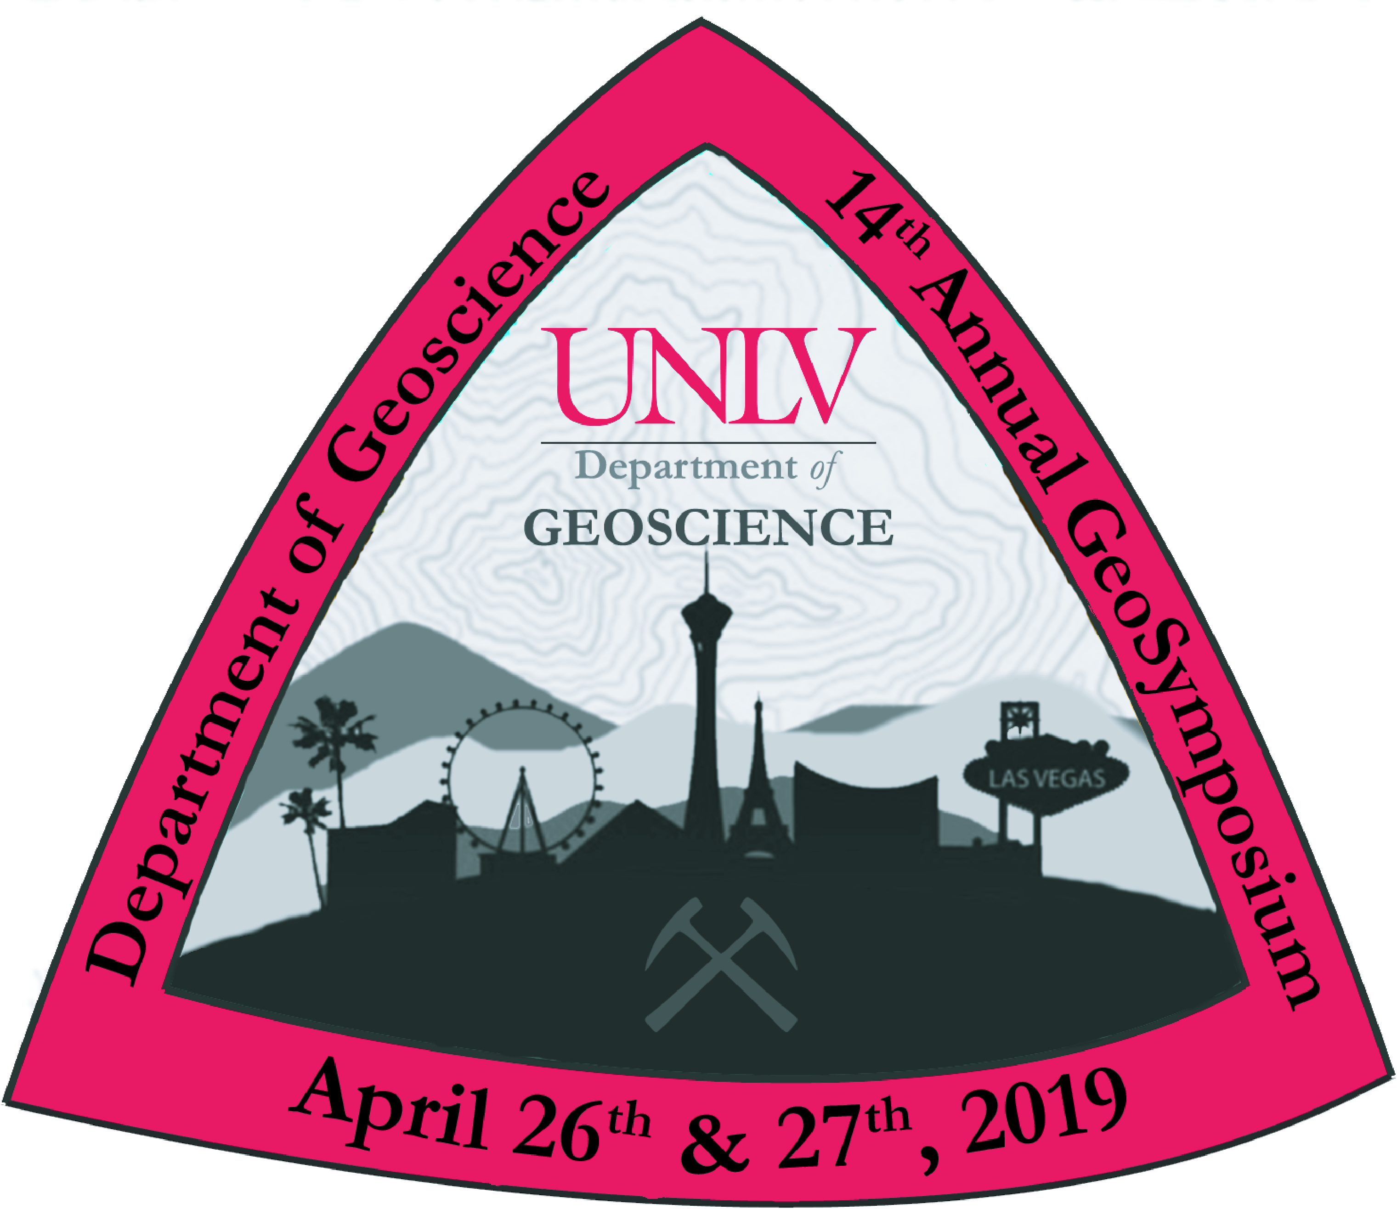
THE 14th ANNUAL UNLV GEOSYMPOSIUM

APRIL 26, 2019

TITLE (CAps, Times NEW ROMAN 14, Bold)

Author Name¹, and Author Name² . . .
1-Author Affiliation (Institution, City, State, Country)
2-Author Affiliation (if different from first)
Email @address of primary author

Paste your abstract here – 300 words or less; 12 pt regular font Times New Roman, single-spaced, no indent at the beginning of paragraphs, one line between paragraphs.

Please save this document as “LAST NAME OF 1st AUTHOR_GSP_Abstract_poster OR talk” (depending on which one you choose)

